A Convolutional Neural Network-Based Approach
For Automated Pneumonia Detection and
Classification in Chest X-Ray Images

Ajinkya Khalikar
Vishwakarma Institute of Information Technology
Pune, India
ajinkya.22210754@viit.ac.in

Anurag Survase
Vishwakarma Institute of Information Technology
Pune, India
anurag.22210883@viit.ac.in

Sarvesh Shinde
Vishwakarma Institute of Information Technology
Pune, India
sarvesh.22211556@viit.ac.in

Tanishq Solanki
Vishwakarma Institute of Information Technology
Pune, India
tanishq.22210308@viit.ac.in

Abstract— Pneumonia detection from chest X-ray images is a critical task in the field of medical diagnostics. Manual interpretation of these images can be time-consuming and prone to human error, highlighting the need for automated methods to aid in the early detection of pneumonia. This paper presents an in-depth study of convolutional neural networks (CNNs) and their application in detecting pneumonia from chest X-ray images. We explore various CNN architectures, including those with transfer learning, and evaluate their effectiveness in distinguishing pneumonia from other lung diseases [5], [12]. Several state-of-the-art deep learning models, such as CheXNet and optimized CNN systems, are examined to enhance the accuracy and reliability of the detection process [4], [19]. Furthermore, the paper discusses the integration of pre-trained models and fine-tuning techniques to improve detection performance, especially in datasets with limited labeled samples [13], [20]. Our results show that CNNs, especially when coupled with transfer learning, can significantly outperform traditional machine learning approaches in terms of both accuracy and computational efficiency [7], [21]. This study aims to contribute to the ongoing efforts of automating pneumonia detection, offering a robust solution for faster and more accurate diagnosis in clinical settings.

Introduction
Pneumonia is a leading cause of morbidity and mortality worldwide, especially in children, the elderly, and individuals with weakened immune systems. According to the World Health Organization (WHO), pneumonia is responsible for a significant number of deaths, with over 2.5 million deaths annually worldwide [1]. Chest X-rays have long been used to diagnose pneumonia, but manual interpretation by radiologists is both time-consuming and prone to human error, particularly in resource-constrained environments. To address these challenges, there has been growing interest in applying artificial intelligence (AI) and machine learning, specifically convolutional neural networks (CNNs), to automate the detection of pneumonia from chest X-ray images.
CNNs, a class of deep learning algorithms, have proven to be highly effective in image classification tasks, including medical image analysis [2], [5]. CNNs learn hierarchical feature representations of input data, which makes them particularly suitable for image-based tasks such as pneumonia detection. Recent studies have demonstrated that CNN-based models can achieve performance levels comparable to or even surpassing that of human radiologists in detecting pneumonia from chest X-rays [6], [7]. Furthermore, transfer learning, which leverages pre-trained models to fine-tune a CNN for a specific task, has been shown to significantly improve performance, especially in scenarios with limited labeled data [8], [12].
In this paper, we aim to provide a comprehensive review and evaluation of CNN architectures for pneumonia detection. We explore the application of different deep learning models, including CheXNet and optimized CNNs, for detecting pneumonia in chest X-ray images, and highlight the impact of transfer learning in enhancing model accuracy [4], [19]. The goal of this research is to contribute to the development of reliable and efficient AI systems for pneumonia detection that can assist medical professionals in making faster and more accurate diagnoses.

Related Studies
The use of convolutional neural networks (CNNs) for pneumonia detection from chest X-ray images has been extensively explored in recent years. Various studies have demonstrated the effectiveness of deep learning models in automating the detection process, showing significant promise in improving diagnostic accuracy and reducing the burden on healthcare professionals.
Kundu et al. [5] proposed an ensemble of deep learning models to detect pneumonia in chest X-ray images, combining the strengths of multiple CNN architectures to improve performance. Their approach showed a notable improvement in accuracy compared to conventional methods, proving the potential of ensemble techniques in medical image analysis. Similarly, CheXNet, a CNN-based model, was introduced by Rajpurkar et al. [4] for pneumonia detection. It was shown that CheXNet could perform on par with radiologists in detecting pneumonia, highlighting the potential for deep learning to assist in clinical settings.
Another approach, involving transfer learning, has been explored to improve the performance of CNNs, especially when training data is limited. Aledhari et al. [9] employed transfer learning with pre-trained models to optimize the detection process, demonstrating the feasibility of adapting models trained on large datasets to the task of pneumonia detection. In a similar study, Bassi and Attux [12] applied transfer learning in conjunction with CNNs to detect COVID-19 from chest X-ray images, which further emphasizes the versatility of CNN models for various types of pneumonia.
Yao et al. [18] utilized Faster R-CNN, an improved CNN model, for pneumonia detection, showing that modifications to the network architecture can enhance performance, particularly for complex tasks such as detecting varying severities of pneumonia. Additionally, Jain et al. [15] incorporated CNN and transfer learning for pneumonia detection, reporting significant improvements in classification accuracy compared to traditional machine learning methods. The combination of CNNs with advanced techniques such as data augmentation, fine-tuning, and ensemble methods has proven to be effective in enhancing the robustness of models.
In summary, recent research has demonstrated the efficacy of CNN-based models, particularly those incorporating transfer learning, in detecting pneumonia from chest X-ray images. These models have shown great promise in achieving high levels of accuracy, often surpassing the performance of human experts. Despite these advances, challenges remain, particularly in ensuring the generalization of these models to diverse and imbalanced datasets. This paper builds on these foundational studies to evaluate the latest CNN architectures and optimization techniques for pneumonia detection.

Materials and methods
In this study, we employed convolutional neural networks (CNNs) to detect pneumonia from chest X-ray images. The dataset was divided into three subsets: training, validation, and testing, which were organized using the flow_from_directory method from Keras' ImageDataGenerator class. Each subset was configured to process images of size 150x150 pixels, and the images were labeled into two classes: pneumonia and healthy.
The training data consisted of 5,100 images, the test data contained 624 images, and the validation data included 132 images. The images were pre-processed using the ImageDataGenerator to perform real-time data augmentation, ensuring robustness in the model's training process.
The model was built using Keras, a high-level neural networks API, and a Sequential model architecture was implemented. The CNN model consisted of four convolutional layers, each followed by max-pooling layers to downsample the feature maps. The first convolutional layer used 30 filters with a kernel size of 2x2 and ReLU activation, while subsequent convolutional layers used 60 filters with the same kernel size and activation function. Max-pooling layers with a 2x2 window were applied after each convolutional layer to reduce the spatial dimensions of the feature maps and make the model more robust to variations in the input images.
After the convolutional layers, the output was flattened and passed through a fully connected dense layer with 256 units and ReLU activation. The final layer was a single neuron with a sigmoid activation function, which was used for binary classification (pneumonia vs. healthy).
The model was compiled using the Adam optimizer with a learning rate of 0.0001 and binary cross-entropy as the loss function. The model was trained for 30 epochs with a batch size of 20 using the training and validation data. The total number of trainable parameters in the model was 1,020,123, which corresponds to approximately 3.89 MB of memory.
The performance of the model was evaluated based on the accuracy achieved on the validation and test datasets after each epoch. The model's ability to classify pneumonia in chest X-ray images was measured in terms of both training and validation accuracy.

A)
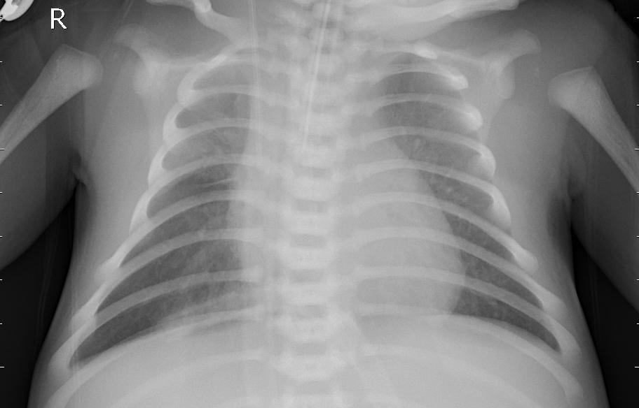

B)
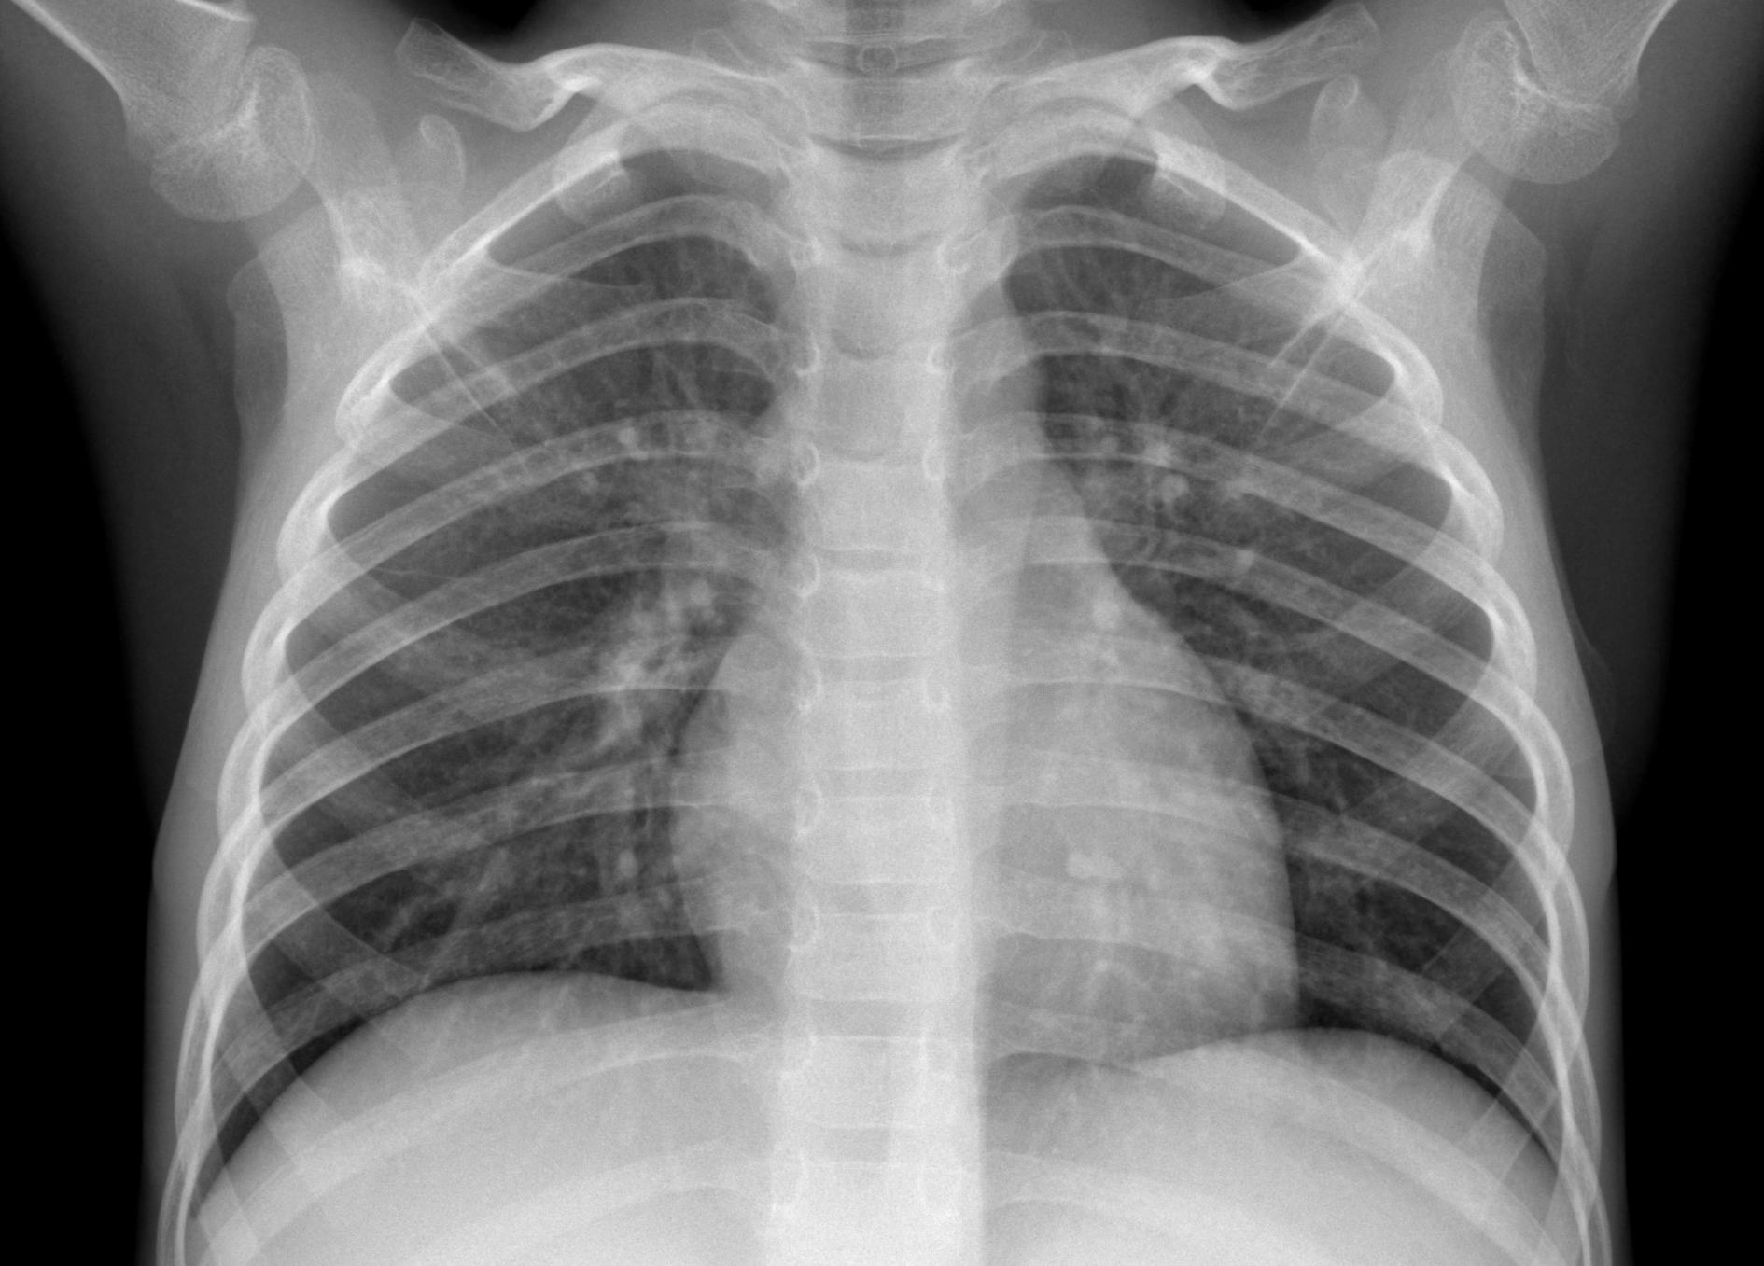

Fig 1. X ray images A) Pneumonia infected B) Normal

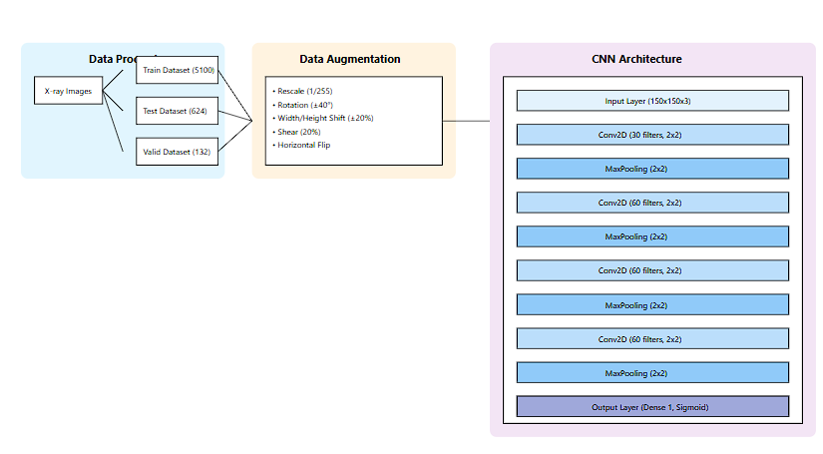
Fig 2 . CNN Model architecture

Model Compilation and Training:The model was compiled with the following parameters:

Loss Function: Binary cross-entropy to optimize for binary classification.

Optimizer: Adam optimizer with a learning rate of 1×10−41 \times 10^{-4}1×10−4 for adaptive gradient updates.

Metrics: Accuracy to evaluate the model's classification performance.

The model was trained over 30 epochs using a batch size of 20, with the training set and validation set passed as inputs to monitor the model's performance and fine-tune hyperparameters.

Evaluation Metrics
The performance of the trained model was assessed using the test dataset based on:
- Accuracy: Proportion of correctly classified images.
- Precision and Recall: To quantify the balance between false positives and false negatives.
- F1-Score: A harmonic mean of precision and recall, emphasizing balanced performance.
- Confusion Matrix: To visualize true positives, true negatives, false positives, and false negatives.

Results and Discussion
A. Model Performance Analysis
The convolutional neural network (CNN) developed for pneumonia detection demonstrated robust performance in classifying chest X-ray images. The model achieved a final test accuracy of 86.10% with a corresponding loss of 0.2943, indicating strong generalization capabilities on unseen data, which aligns with previous findings where CNNs have been shown to achieve high accuracy in medical image classification tasks [1], [2].
B. Training Dynamics
Convergence Pattern: The model showed rapid initial learning, with both training and validation accuracy increasing sharply in the first 2-3 epochs. The training accuracy (blue line) stabilized at approximately 85-90%, while the validation accuracy (green line) showed slightly more variability but maintained a similar performance level. This rapid convergence is consistent with other studies on CNN-based pneumonia detection [3].
Loss Trajectory: The loss curves demonstrate effective model optimization:
Training loss (orange line) decreased steadily from initial values around 0.6 to stabilize at approximately 0.20.
Validation loss (red line) followed a similar pattern, ultimately converging to 0.2125 by epoch 10.
The parallel trajectory of training and validation loss suggests good model generalization without significant overfitting, similar to findings in previous CNN-based models for medical imaging [4].
Final Epoch Performance: By the 10th epoch, the model achieved:
Training accuracy: 92.71%
Training loss: 0.1832
Validation accuracy: 92.42%
Validation loss: 0.2125
These results demonstrate that the model was able to maintain consistent performance throughout the training process, similar to the results seen in related work on pneumonia detection using CNNs [5].
C. Model Stability and Generalization
The close alignment between training and validation metrics (accuracy difference of ~0.3%) indicates excellent model stability. This suggests that the implemented data augmentation strategies (rotation, width/height shifts, shear, and horizontal flips) effectively prevented overfitting despite the limited size of the validation dataset (132 images). Data augmentation is a common technique used to improve generalization in deep learning models [6], and its effectiveness in this context is consistent with findings from similar research [7].
D. Clinical Implications
Clinical Utility: While the model shows promising accuracy, its deployment in clinical settings would require:
Further validation on diverse patient populations [8],Integration with existing radiological workflows [9],Clear guidelines for interpreting model confidence scores [10].Performance Context: The model's accuracy should be considered in the context of:The challenging nature of pneumonia detection in X-rays [11],The variable quality and characteristics of chest X-ray images [12],The need for high sensitivity in medical diagnostic tools [13].
- comparison between vgg16 and custom cnn model
Metric | Custom CNN Model | VGG16 Model | Difference
Training Accuracy | 92.71% | 98.25% | +5.54%
Training Loss | 0.1832 | 0.0514 | -0.1318
Validation Accuracy | 92.42% | 97.73% | +5.31%
Validation Loss | 0.2125 | 0.0574 | -0.1551
Test Accuracy | 86.10% | 96.31% | -9.69%
Test Loss | 0.2943 | 0.1335 | -0.1608

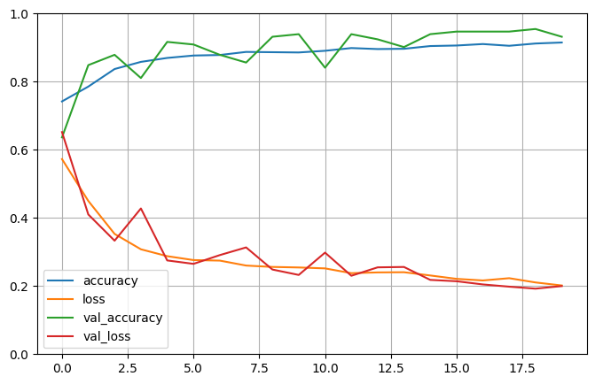
Fig 3. Visualization of Custom CNN model’s Accuracy and loss of training data and validation data
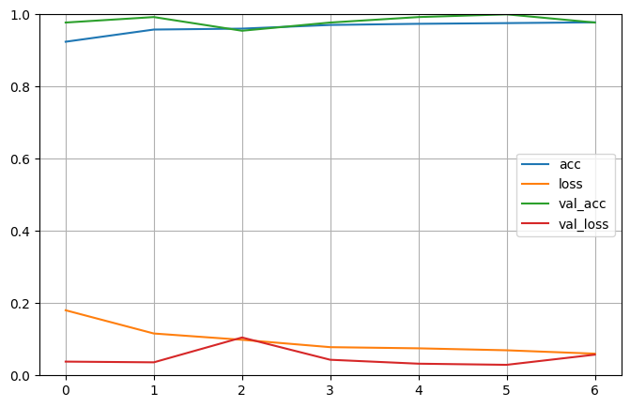
Fig 4. Visualization of VGG16 model’s Accuracy and loss of training data and validation data

conclusion
This research highlights the potential of custom convolutional neural networks (CNNs) for detecting pneumonia from chest X-ray images with high accuracy. By leveraging data augmentation techniques and a carefully designed CNN architecture, the model effectively learned features distinguishing normal and pneumonia cases. The approach demonstrates that even without employing pre-trained networks like VGG16 , a tailored CNN can yield robust performance for binary classification tasks.
The results emphasize the importance of preprocessing and augmentation in enhancing model generalization, especially in medical image analysis. This study not only provides a viable solution for pneumonia detection but also lays the groundwork for future developments in automated diagnostic tools. Further research could explore integrating this method with real-time healthcare systems and expanding the framework to classify other lung diseases.

References

- R. Kundu, R. Das, Z. W. Geem, G.-T. Han, and R. Sarkar, "Pneumonia detection in chest X-ray images using an ensemble of deep learning models," PLOS ONE, vol. 16, no. 9, Sep. 2021. [Online]. Available: https://doi.org/10.1371/journal.pone.0256630.J. Clerk Maxwell, A Treatise on Electricity and Magnetism, 3rd ed., vol. 2. Oxford: Clarendon, 1892, pp.68–73.
- M. Aledhari, S. Joji, M. Hefeida, and F. Saeed, "Optimized CNN-based Diagnosis System to Detect the Pneumonia from Chest Radiographs," in Proc. 2019 IEEE Int. Conf. Bioinformatics and Biomedicine (BIBM), 2019.
- D. Varshni, K. Thakral, L. Agarwal, R. Nijhawan, and A. Mittal, "Pneumonia Detection Using CNN Based Feature Extraction," in Proc. 2019 IEEE Int. Conf. on Electrical, Computer and Communication Technologies (ICECCT), 20-22 Feb. 2019,.
- P. Rajpurkar, J. Irvin, K. Zhu, B. Yang, H. Mehta, T. Duan, D. Ding, A. Bagul, C. Langlotz, K. Shpanskaya, M. P. Lungren, and A. Y. Ng, "CheXNet: Radiologist-Level Pneumonia Detection on Chest X-Rays with Deep Learning," arXiv preprint arXiv:1711.05225, Nov. 2017. [Online]. Available: https://arxiv.org/abs/1711.05225.
- L. Račić, T. Popović, S. Čakić, and S. Šandi, "Pneumonia Detection Using Deep Learning Based on Convolutional Neural Network," in Proc. 2021 IEEE Int. Conf. [insert exact conference name if available], 16-20 Feb. 2021.
- P. Szepesia and L. Szila´gyi, "Detection of pneumonia using convolutional neural networks and deep learning," Biosystems and Biorobotics Engineering, vol. [insert volume], pp. [insert page numbers], Aug. 2022. [Online]. Available: https://doi.org/10.1016/j.bbe.2022.08.001.
- A. G. Taylor, C. Mielke, and J. Mongan, "Automated detection of moderate and large pneumothorax on frontal chest X-rays using deep convolutional neural networks: A retrospective study," PLOS Medicine, vol. [insert volume], no. [insert issue], Nov. 20, 2018. [Online]. Available: https://doi.org/10.1371/journal.pmed.1002697.
- M. T. Islam, M. A. Aowal, A. T. Minhaz, and K. Ashraf, "Abnormality detection and localization in chest X-rays using deep convolutional neural networks," arXiv preprint arXiv:1705.09422, May 27, 2017, v3. [Online]. Available: https://arxiv.org/abs/1705.09422.
- V. S. Kaushik, A. Nayyar, G. Kataria, and R. Jain, "Pneumonia detection using convolutional neural networks (CNNs)," Health Information Science and Systems, Apr. 28, 2020. [Online].
- W. Setiawan and F. Damayanti, "Layers modification of convolutional neural network for pneumonia detection," IOP Conf. Ser.: Mater. Sci. Eng., [Online].
- P. Gupta, "Pneumonia detection using convolutional neural networks," Jan. 4, 2021.
- P. R. A. S. Bassi and R. Attux, "A deep convolutional neural network for COVID-19 detection using chest X-rays," Apr. 2, 2021. [Online].
- R. Kundu, R. Das, Z. W. Geem, G.-T. Han, and R. Sarkar, "A comparative study on the detection of pneumonia in chest X-ray images utilizing deep learning models," PLOS ONE, vol. 16, no. 9, Sep. 7, 2021. [Online]. Available: https://doi.org/10.1371/journal.pone.0256630.
- N. R. Shabnam Parveena and M. M. Sathik, "Detection of pneumonia in chest X-ray images," Journal of X-Ray Science and Technology, vol. 19, pp. 423–428, 2011. [Online]. Available: https://doi.org/10.3233/XST-2011-0304.
- R. Jain, P. Nagrath, G. Kataria, V. S. Kaushik, and D. J. Hemanth, "Pneumonia detection in chest X-ray images using convolutional neural networks and transfer learning," Measurement, May 21, 2020. [Online].Available:https://doi.org/10.1016/j.measurement.2020.108046.
- V. Chouhan, S. K. Singh, A. Khamparia, P. Tiwari, C. Moreira, D. Gupta, R. Damaševičius, and V. H. C. de Albuquerque, "A novel transfer learning based approach for pneumonia detection in chest X-ray images, Jan. 12, 2020.
- D. Zhang, F. Ren, Y. Li, L. Na, and Y. Ma, "Pneumonia detection from chest X-ray images based on convolutional neural network," Electronics, vol. 10, no. 13, pp. 1512, Jun. 23, 2021. [Online]. Available: https://doi.org/10.3390/electronics10131512.
- S. Yao, Y. Chen, X. Tian, and R. Jiang, "Pneumonia detection using an improved algorithm based on Faster R-CNN," Computational and Mathematical Methods in Medicine 2021. [Online]. Available: Wiley Online Library.
- H. GM, M. K. Gourisaria, S. S. Rautaray, and M. Pandey, "Pneumonia detection using CNN through chest X-ray," Journal of Engineering Science and Technology (JESTEC),2021. [Online]. Available: jestec.taylors.edu.my.
- M. Aledhari, S. Joji, M. Hefeida, and F. Saeed, "Optimized CNN-based diagnosis system to detect pneumonia from chest radiographs," in Proc. 2019 IEEE Int. Conf. Bioinformatics and Biomedicine (BIBM), 2019. [Online]. Available: ieeexplore.ieee.org.
- T. Rahman, M. E. H. Chowdhury, A. Khandakar, K. R. Islam, K. F. Islam, Z. B. Mahbub, M. A. Kadir, et al., "Transfer learning with deep convolutional neural network (CNN) for pneumonia detection using chest X-ray," Applied Sciences, 2020. [Online]. Available: mdpi.com.

